1. Design a hardware module to implement Extended Euclidean Algorithm. Such that given integers a and b, it will provide a-1mod b where b is a prime number.

2. Design a hardware module to implement the PRESENT S-Box such that for the input x it will provide output S(x).  
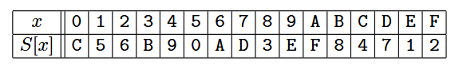  
a) Implement the naïve architecture by case statement.  
b) Implement it using combinational circuit for area optimization.